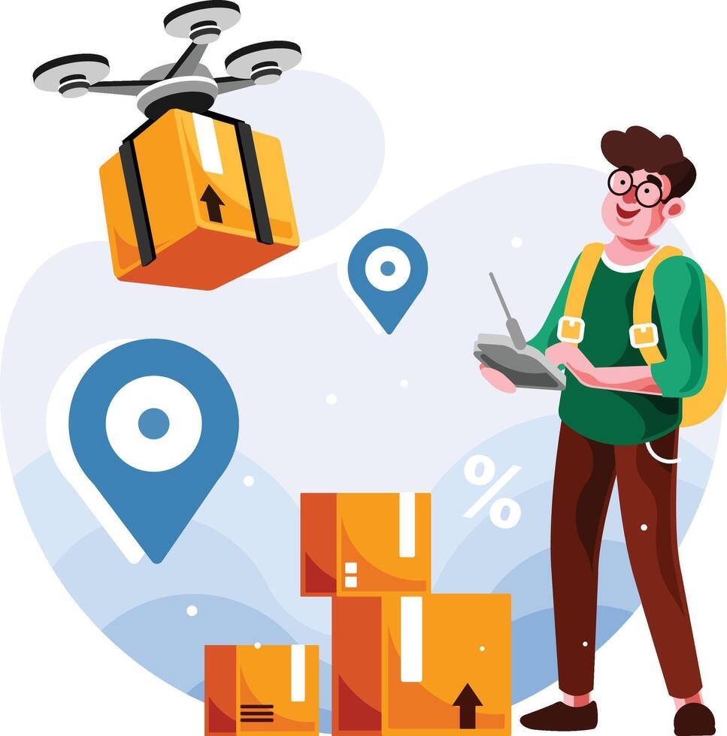  EcoDash | name: firdaus Ebrahim  student number :25302156  module code: WAS262  Due date: 28 september 2026

African Context Report
Challenge
EcoDash is a game based on the real-world challenges of having medical supplies delivered to rural areas in South Africa. Many rural residents live a distance away from medical services and hence may face challenges due to long commutes, a lack of transportation options, and bad road conditions. The Rural Health Advocacy Project remarks that, inadequate transportation and bad roads can hinder rural residents’ access to medical facilities and also have an impact on the provision of healthcare services.
We also see how a solar-powered medical delivery drone might help address this issue. The done can travel across the rural area in order to deliver medical supplies, instead of depending on road transport alone. South Africa has already started its investigation in Drone Technology for healthcare purposes’ . E.g. The South African National Blood Service shows the use that the use of drones can enhance the quick delivery of blood products, especially to remote regions.
The game also includes environmental factors that could potentially affect the delivery drone. These factors include but are not limited to wind, wildlife, nature(trees), etc. The use of renewable energy infrastructures where access to reliable energy may be limited this is demonstrated using a solar charging zone.
Mathematics and Physics Model
The following mathematics and physics models were used to create my game:
- Velocity controls how fast the drone will move horizontally and vertically.
- Acceleration gradually increases the drones speed as the player moves.
- Friction slows down the drone the movement keys are released.
- Trigonometry (Math.sin() and Math.cos() ) controls the direction the drone moves based on its angle.
- Pythagoras calculators are used to calculate total speed and bird collision distance.
- Wind force slightly changes the drone’s horizontal movement.
- Battery calculations reduce energy while flying and can then recharge inside the solar charging zone
- AABB collision detection is used for rectangular objects such as the delivery point and the solar charging zone
- Circular distance collision Is used to detect collisions between the drone and the birds

